**Array**

* An Array is a [Linear data structure](https://www.faceprep.in/data-structures/types-of-data-structures/)
* It is a collection of data items having similar data types stored in contiguous memory locations.
* By knowing the address of the first item we can easily access all items/elements of an array.
* Arrays and its representation is given below.

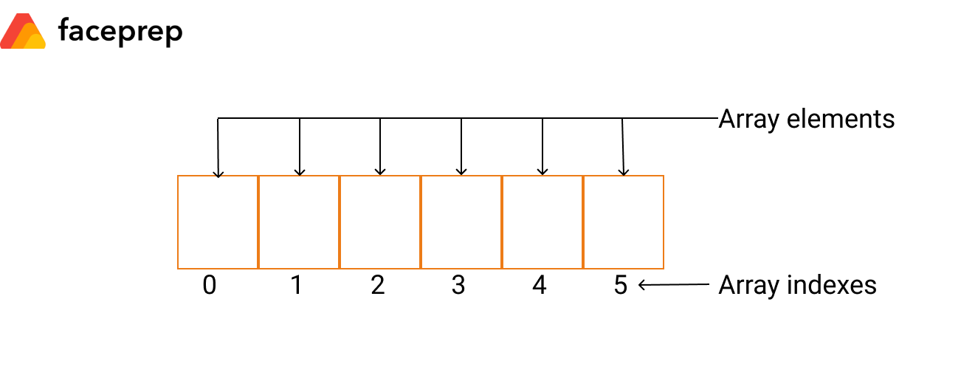

* Array Dsicription:
  + **Array Index:**The location of an element in an array has an index, which identifies the element. Array index starts from 0.
  + **Array element:**Items stored in an array is called an element. The elements can be accessed via its index.
  + **Array Length:** The length of an array is defined based on the number of elements an array can store. In the above example, array length is 6 which means that it can store 6 elements.
* When an array of size and type is declared, the compiler allocates enough memory to hold all elements of data.
* E.g. an array face [10] will have 10 elements with index starting from 0 to 9 and the memory allocated contiguously will be 20 bytes (integer = 2 bytes).
* The compiler knows the address of the first byte of the array only. Also, the address of the first byte is considered as the memory address for the whole array.

**Types of Arrays**

The various types of arrays are as follows.

* One dimensional array
* Multi-dimensional array
* **One-Dimensional Array**
  + A one-dimensional array is also called a single dimensional array
  + where the elements will be accessed in sequential order.
  + This type of array will be accessed by the subscript of either a column or row index.
* **Multi-Dimensional Array**
  + When the number of dimensions specified is more than one, then it is called as a multi-dimensional array.
  + Multidimensional arrays include 2D arrays and 3D arrays.

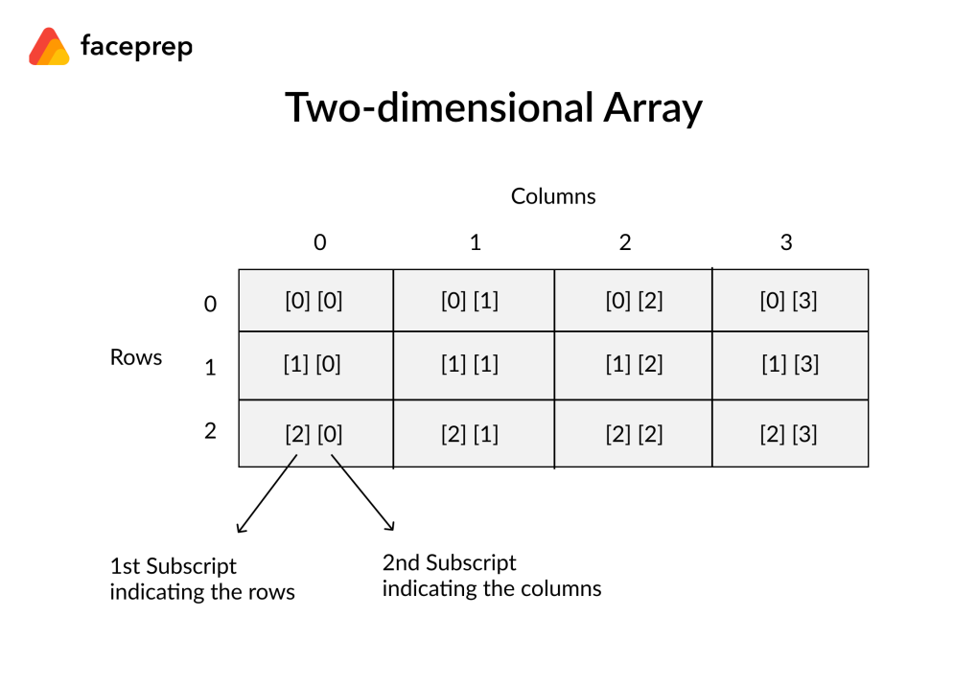

* **E.g. A two-dimensional array**
  + Accessed with subscript of row and column index
  + For traversal the value of the rows and columns will be considered
  + E.g. **face [3] [4],** the first index specifies the number of rows and the second index specifies the number of columns and the array can hold 12 elements (3 * 4)
* **A three-dimensional array**
  + The array **face [5] [10] [15]** can hold 750 elements (5 * 10 * 15).

**Address Calculation in single (one) Dimension Array:**

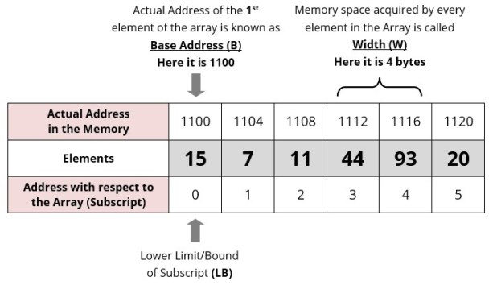

* Address of an element A[ I] is calculated using the following formula:
* 1100 + (1—0) *4
* 1100 + (4-0) * 4
  + **Address of A [ I ] = B + W * ( I – LB )**
  + Where,  
    **B** = Base address  
    **W** = Storage Size of one element stored in the array (in byte)  
    **I** = Subscript of element whose address is to be found

**LB** = Lower limit / Lower Bound of subscript, if not specified assume 0 (zero)

* + **Example:**

**Base address** of an array**B[1300…..1900]**as **1020 and size of each element** is **2 bytes in the memory. Find the address of B[1700]**

**Solution:**

**Sol : B = 1020, LB = 1300, W = 2, I = 1700**

**Address of A [ I ] = B + W * ( I – LB )**

= 1020 + 2 * (1700 – 1300)

= 1020 + 2 * 400  
 = 1020 + 800  
 = 1820

**Why does Array Indexing start with 0?**

* Here **a** itself is a pointer which contains the memory location of the first element of the array
* first element can be accessed with **a[0]**
  + internally decoded by the compiler as **\*(a + 0)**.
* second element can be accessed by **a[1]** or **\*(a + 1)**.
* As **a** contains the address of the first element = Base Address
* and index describes the offset from the first element, i.e. the distance from the first element.
* If array indexing starts at 1 instead of 0
* the first element can be accessed by **a[1]**
  + - which is internally decoded as **\*(a + 1 – 1)**.
* Thus we have to perform one extra operation i.e. subtraction by 1.
* This extra operation will greatly decrease the performance when the program is big.
* Thus to avoid this extra operation and improve the performance, array indexing starts at 0 and not at 1.

**Address Calculation in Double (Two) Dimensional Array:**

* While storing the elements of a 2-D array in memory, these are allocated contiguous memory locations.
* Therefore, a 2-D array must be linearized so as to enable their storage.
* There are two alternatives to achieve linearization:
  + Row-Major
  + Column-Major.

[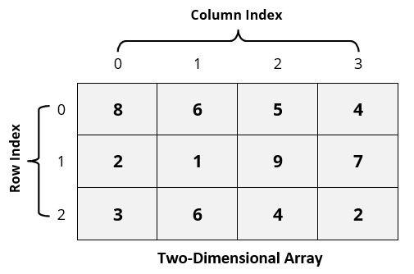](https://i2.wp.com/www.guideforschool.com/wp-content/uploads/2013/11/two-dimensional-array-memory-address-calculation.jpg)

[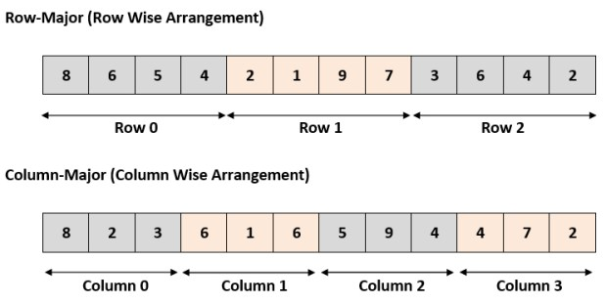](https://i2.wp.com/www.guideforschool.com/wp-content/uploads/2013/11/row-major-column-major-memory-address-calculation.jpg)

|  |  |  |  |  |  |  |  |  |  |  |  |
| --- | --- | --- | --- | --- | --- | --- | --- | --- | --- | --- | --- |
| **0** | **1** | **2** | **3** | **4** | **5** | **6** | **7** | **8** | **9** | **10** | **11** |

* Address of an element A[ I ][ J ] = = B + W * [ N * ( I – Lr ) + ( J – Lc ) ] for thr array declared as A[M][N]

Where

**B** = Base address  
**I** = Row subscript of element whose address is to be found  
**J** = Column subscript of element whose address is to be found  
**W** = Storage Size of one element stored in the array (in byte)  
**Lr** = Lower limit of row/start row index of matrix, if not given assume 0 (zero)  
**Lc** = Lower limit of column/start column index of matrix, if not given assume 0 (zero)  
**M** = Number of row of the given matrix  
**N** = Number of column of the given matrix

Example : for the given A[4][4] with A[0..3][0..3]

* + Address of A[1][1] = B + W * [4 * (1-0) + (1-0)]

= B + W *[5]

**Column Oriented storage :**



* **Address of A[ I ][ J ] = B + W * [M*( J – Lc ) + ( I – Lr )]**

Where

**B** = Base address  
**I** = Row subscript of element whose address is to be found  
**J** = Column subscript of element whose address is to be found  
**W** = Storage Size of one element stored in the array (in byte)  
**Lr** = Lower limit of row/start row index of matrix, if not given assume 0 (zero)  
**Lc** = Lower limit of column/start column index of matrix, if not given assume 0 (zero)  
**M** = Number of row of the given matrix  
**N** = Number of column of the given matrix

* **Important Note :**
  + Usually number of rows and columns of a matrix are given ( like A[20][30] or A[40][60] ) but if it is given as **A[Lr- – – – – Ur, Lc- – – – – Uc]**. In this case number of rows and columns are calculated using the following methods:
    - Number of rows (**M**) will be calculated as = **(Ur – Lr) + 1**  
      Number of columns (**N**) will be calculated as = **(Uc – Lc) + 1**
    - And rest of the process will remain same as per requirement (Row Major Wise or Column Major Wise).

**Examples:**

**Q 1**. An array X [-15……….10, 15……………40] requires **one byte of storage**. If beginning location is 1500 determine the location of X [15][20].

**Q 1**. An array X [-15……….10, 15……………40] requires **one byte of storage**. If beginning location is 1500 determine the location of X [15][20].

**Solution:**

As you see here the number of rows and columns are not given in the question. So they are calculated as:

Number or rows say **M = (Ur – Lr) + 1** = [10 – (- 15)] +1 = 26  
Number or columns say **N = (Uc – Lc) + 1** = [40 – 15)] +1 = 26

**(i) Row Major Wise Calculation of above equation**

The given values are: B = 1500, W = 1 byte, I = 15, J = 20, Lr = -15, Lc = 15, N = 26

Address of A [ I ][ J ] = B + W * [ N * ( I – Lr ) + ( J – Lc ) ]

= 1500 + 1* [26 * (15 – (-15))) + (20 – 15)]

= 1500 + 1 * [26 * 30 + 5]

= 1500 + 1 * [780 + 5]

= 1500 + 785  
= 2285 **[Ans]**

**Q 1**. An array X [-15……….10, 15……………40] requires **one byte of storage**. If beginning location is 1500 determine the location of X [15][20].

**Solution:**

As you see here the number of rows and columns are not given in the question. So they are calculated as:

Number or rows say **M = (Ur – Lr) + 1** = [10 – (- 15)] +1 = 26  
Number or columns say **N = (Uc – Lc) + 1** = [40 – 15)] +1 = 26

**(i) Row Major Wise Calculation of above equation**

The given values are: B = 1500, W = 1 byte, I = 15, J = 20, Lr = -15, Lc = 15, N = 26

Address of A [ I ][ J ] = B + W * [ N * ( I – Lr ) + ( J – Lc ) ]

= 1500 + 1* [26 * (15 – (-15))) + (20 – 15)]

= 1500 + 1 * [26 * 30 + 5]

= 1500 + 1 * [780 + 5]

= 1500 + 785  
= 2285 **[Ans]**

**(ii) Column Major Wise Calculation of above equation**

The given values are: B = 1500, W = 1 byte, I = 15, J = 20, Lr = -15, Lc = 15, M = 26

Address of A [ I ][ J ] = B + W * [ ( I – Lr ) + M * ( J – Lc ) ]

= 1500 + 1 * [(15 – (-15)) + 26 * (20 – 15)]

= 1500 + 1 * [30 + 26 * 5]

= 1500 + 1 * [160]

= 1660 **[Ans]**

**Total memory allocated to an Array = Number of elements * size of one element**

**Single Dimension:**

Total memory allocated for an Integer Array of N elements

= Number of elements * size of one element  
= N * 4 bytes  
= 10 * 4 bytes = **40 Bytes**, where N = 10  
= 500 * 4 bytes = **2000 Bytes**, where N = 500

Total memory allocated for an character Array of N elements

= Number of elements * size of one element  
= N * 1 Byte  
= 10 * 1 Byte = **10 Bytes**, where N = 10  
= 500 * 1 Byte = **500 Bytes**, where N=500

**Two Dimensions :**

**Total memory allocated for 2D Array**

= Number of elements * size of one element  
= Number of Rows * Number of Columns * Size of one element

**Total memory allocated for an Integer Array of size M X N**

= Number of elements * size of one element  
=M Rows* N Columns * 4 Bytes  
= 10*10 * 4 bytes = **400 Bytes**, where M =N = 10  
= 500*5 *4 bytes= **10000 Bytes**, where M=500 and N= 5

**Total memory allocated for a character Array of N elements**

= Number of elements * size of one element  
= M Rows* N Columns * 1 Byte  
= 10*10 * 1 Byte = **100 Bytes**, where N = 10  
= 500*5 * 1 Byte = **2500 Bytes**, where M=500 and N= 5

**Example 2:**

Each element of an array arr[15][20] requires ‘W’ bytes of storage. If the address of arr[6][8] is 4440 and the base address at arr[1][1] is 4000, find the width ‘W’ of each cell in the array arr[][] when the array is stored as Column Major Wise.

**Solution: Example 2:**

Each element of an array **arr[15][20] requires** ‘W’ bytes of storage. If the **address of arr[6][8] is 4440** and the **base address at arr[1][1]** is 4000, find the width ‘W’ of each cell in the array arr[][] when the array is stored as **Column Major Wise**.

Given :

**B** = Base address = 4000  
**I** = Row subscript of element whose address is to be found = 6  
**J** = Column subscript of element whose address is to be found = 8  
**W** = Storage Size of one element stored in the array (in byte) = NOT Given  
**Lr** = Lower limit of row/start row index of matrix = 1

**Lc** = Lower limit of column/start column index of matrix = 1  
**M(or R)** = Number of row of the given matrix = 15  
**N (or C)** = Number of column of the given matrix = 20

**Solution: Example 2:**

Each element of an array **arr[15][20] requires** ‘W’ bytes of storage. If the **address of arr[6][8] is 4440** and the **base address at arr[1][1]** is 4000, find the width ‘W’ of each cell in the array arr[][] when the array is stored as **Column Major Wise**.

Given :

**B** = Base address = 4000  
**I** = Row subscript of element whose address is to be found = 6  
**J** = Column subscript of element whose address is to be found = 8  
**W** = Storage Size of one element stored in the array (in byte) = NOT Given  
**Lr** = Lower limit of row/start row index of matrix = 1

**Lc** = Lower limit of column/start column index of matrix = 1  
**M(or R)** = Number of row of the given matrix = 15  
**N (or C)** = Number of column of the given matrix = 20

Address of [I, J]th element in column-major

= B + W[R(J – Lc) + (I – Lr)]  
⇒ 4440 = 4000 + W[15(8 – 1) + (6 – 1)]  
⇒ 4440 = 4000 + W[15(7) + 5]  
⇒ 4440 = 4000 + W[105 + 5]  
⇒ 4440 = 4000 + W[110]  
⇒ W[110] = 440  
⇒ W = 4.



**Example 3:**

A matrix ARR[-4…6, 3…8] is stored in the memory with each element requiring 4 bytes of storage. If the base address is 1430, find the address of ARR[3][6] when the matrix is stored in Row Major Wise.

Given :

**B** = Base address = 1430  
**I** = Row subscript of element whose address is to be found = 3  
**J** = Column subscript of element whose address is to be found = 6  
**W** = Storage Size of one element stored in the array (in byte) = 4  
**Lr** = Lower limit of row/start row index of matrix = -4

**Lc** = Lower limit of column/start column index of matrix = 3  
**M(or R)** = Number of row of the given matrix = 6 – (-4) + 1 = 11  
**N (or C)** = Number of column of the given matrix = 8 – 3 +1 = 6

**Example 3:**

A matrix ARR[-4…6, 3…8] is stored in the memory with each element requiring 4 bytes of storage. If the base address is 1430, find the address of ARR[3][6] when the matrix is stored in Row Major Wise.

Given :

**B** = Base address = 1430  
**I** = Row subscript of element whose address is to be found = 3  
**J** = Column subscript of element whose address is to be found = 6  
**W** = Storage Size of one element stored in the array (in byte) = 4  
**Lr** = Lower limit of row/start row index of matrix = -4

**Lc** = Lower limit of column/start column index of matrix = 3  
**M(or R)** = Number of row of the given matrix = 6 – (-4) + 1 = 11  
**N (or C)** = Number of column of the given matrix = 8 – 3 +1 = 6

**Address of [I, J]th element in row-major**

= B + W[C(I – Lr) + (J – Lc)]  
⇒ Address of ARR[3][6] = 1430 + 4[6(3 – (-4)) + (6 – 3)]  
⇒ Address of ARR[3][6] = 1430 + 4[6(3 + 4) + 3]  
⇒ Address of ARR[3][6] = 1430 + 4[6(7) + 3]  
⇒ Address of ARR[3][6] = 1430 + 4[42 + 3]  
⇒ Address of ARR[3][6] = 1430 + 4[45]  
⇒ Address of ARR[3][6] = 1430 + 180  
⇒ Address of ARR[3][6] = 1610.